The Afghan Church, Bombay
By Sue Bush

Part 1: THE 3 AFGHAN WARS – 1839 TO 1919 Part 1
3 Afghan wars were fought between the British and the Afghans for the land of Kabul to keep the British territory of India safe from Russian powers, who may possibly lay siege to India via the Khyber and Bolan passes in Afghanistan.
These events dubiously nicknamed “the Great Game” resulted in devastating losses to both British and Indian soldiers, But eventually the British were unable to maintain their hold over Kabul as they had over India.
The end of the first Afghan war resulted in the survival of only 10 people from the 44th Foot Regiment (mostly Indian soldiers) and only one returned to Jalalabad – a Dr. Willian Brydon. Elizabeth Butlers painting of this image spoke volumes of the horror of that war.

(Picture removed for copyright reasons)

With all the conspiracies, subterfuge and political intrigue between 1839 and 1919 many soldiers lost their lives either in battle or on the unforgiving and unyielding terrain of Afghanistan. However by the end of the3rd Afghan war, the famous Durand line was reaffirmed as the boundary separating N.India from Afghanistan.
A small victory for Britian in the light of the heavy losses by way of soldiers, both Indian and British. An undertaking to stop interference in the Northern frontier by the Afghanis was another positive result, well, for what it was worth for the moment anyway.
The relations between Afghanistan and the British remained uneasy until the end of their reign in India.

The Afghan War Memorial Church (St. John the Evangelist church) – celebrated 153 years 7th Jan 2011.
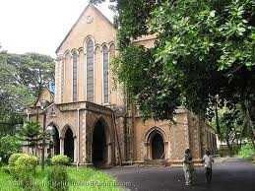

When you’re wounded and left on Afghanistan’s plains,
And the women come out to cut up what remains,
Jest roll to your rifle and blow out your brains
An’ go to your Gawd like a soldier.
Go, go, go like a soldier,
Go, go, go like a soldier,
Go, go, go like a soldier,
So-oldier of the Queen!”
-- Rudyard Kipling, THE YOUNG BRITISH SOLDIER

In 1847 a church was built as a memorial to the soldiers both Indian and British who fought and died in the first Afghan war of 1838. Also known as St. John Evangelical church, it is located in what is now the Navy cantonment area. Isolated and quiet from the rest of the ever bustling city, the church is nestled somewhere in the middle of this area.
Originally selected by the East India Company for its remoteness for military cantonment area, the spot where the church stands was originally a chapel. Near it was a “Sick Bungalow” for recuperating soldiers, which is now a complete hospital known as INS Ashwini for members of the Navy. Members of the church had to bring their own chairs for the service (how cool is that???)
Permission was given by the government to build a church on the spot where the chapel stood, provided its steeples were built tall enough to be seen out at sea as a landmark to guide ships into the harbour. The steeple stands 198 ft (60 mtrs.) tall. Actually it can still be seen from a lighthouse in the Arabian Sea.
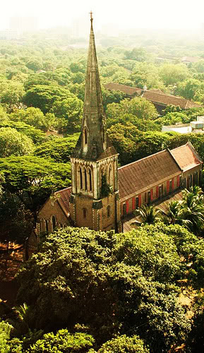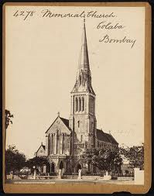
Aerial view of the famous spire Afghan Church then
(This navy cantonment area is at the very end of the island of Mumbai) which as you know is an island and therefore close to the sea.
The church was founded by Rev. G. Piggot, designed by Henry Conbeare, city engineer and its architect was the Victorian William Butterfield. The church was consecrated on January 7, 1858 by Bishop Harding.
An imposing basalt structure with a towering limestone spire, the church is impressive with its wide Gothic arches and beautiful stained-glass windows.
The walls are made of rubble and faced with coarse Kurla stone (buff coloured basalt). Piers arches and dressings are of Porbunder Stone, similar to the Caen Stone of the English churches.
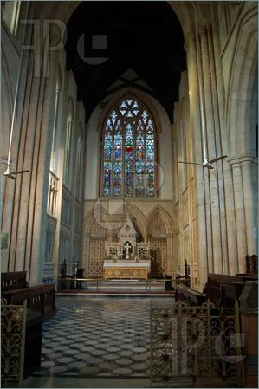
The altar of the church and the kneeling cushions up front for receiving communion
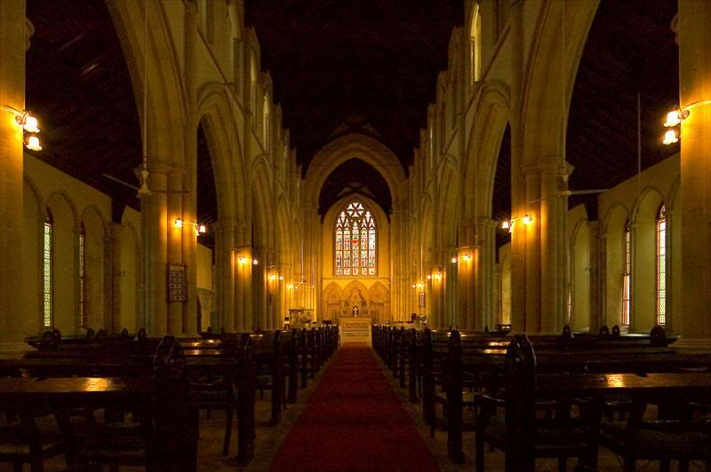
The aisle of Afghan Church & the exceptionally clean varnished teakwood ceiling !!!
If you look closely you will spot the semi circular slot cut out on the last pews. These are at regular intervals down all pews..for resting guns.!! .At the far end of every 2nd or 3rd pew (near the aisle) is a circular cut out for the regiment flag. I don’t know what guns were doing in the church, though it makes for sensational history when one is seeing it first hand.
The ceiling is constructed with varnished teakwood beams with hammer beam style ribbing.are surprisingly clean considering its height.
Besides the British soldiers, it also commemorates different Indian regiments, including the Bombay Army, the Madras Army, and Ranjit Singh's army from Lahore..
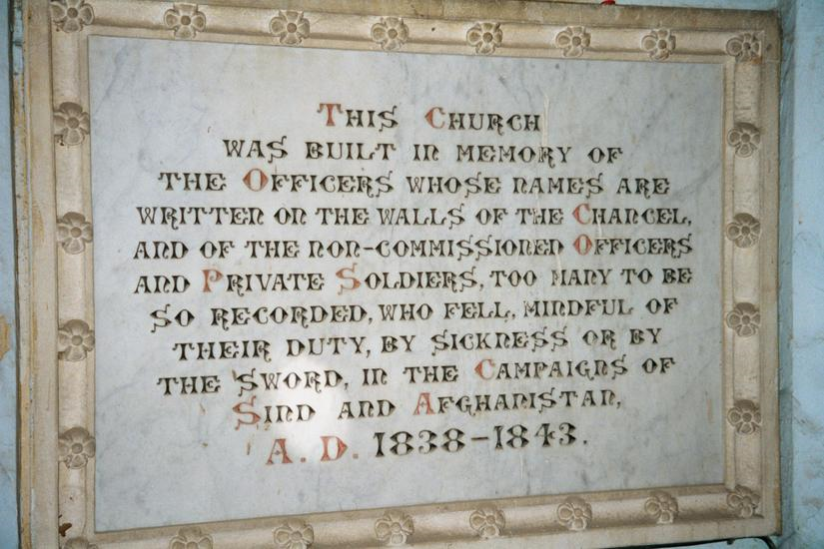
Another inscription reads : TO THE GLORY OF GOD AND IN MEMORY OF PERCY CHARLES HEATH -CAPTAIN BOMBAY STAFF CORPS THIRD SON OF THE LATE MAJOR GENERAL J.C. HEATH BOMBAY ARMY BORN 11TH APRIL 1847 KILLED AT THE BATTLE OF MAIWAND AFGHANISTAN JULY 27TH 1880.
THIS MEMORIAL IS PLACED HERE BY HIS BROTHERS IN LOVING REMEMBRANCE “THE TRUMPET SHALL SOUND / AND THE DEAD SHALL BE RAISED”

And yet another : “IN LOVED MEMORY OF MAJOR SIR PIERRE LOUIS NAPOLEON CAVAGNARI K.C.B. C.S.I.B.S.C. POLITICAL OFFICER WITH /THE BRITISH TROOPS IN AFGHANISTAN AND ENVOY TO THE COURT OF KABUL . HE FELL WITH THE MEMBERS OF HIS ESCORT WHILST GALLANTLY DEFENDING THE RESIDENCY AT KABUL AGAINST OVERWHELMING NUMBERS 3RD SEPTEMBER 1879 AGED 37.”

The church still looks good and retains its 21 stained glass windows which were imported from England and one of its finest features is the Great East & West window designed by James Wailles, stained glass expert during the mid-1800s. It is said to be the finest stained glass window in all of Mumbai. Apparently though Ive read that it is need of extensive renovation to retain the structure

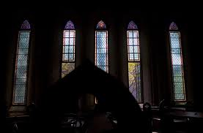
The famous Afghan Church windows
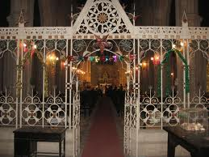
At the entrance, this small space before leading into the main part of the seating arrangement of the church. To the right of the picture the glass flag cabinets...opposite plaques with names of more solders, officers.
The feature that needs mention is the bell tower and the peals of its eight bells that remain unrivalled in western India. Eight bells usually take anything from two and a half hours to fours to ring and have 40,320 changes. The bells themselves came from the Taylor Bell Foundry of England in 1904 and can be seen several miles away. They are known to be the best in W.India.

