The Afghan Church, Bombay
By Sue Bush

Part 2:

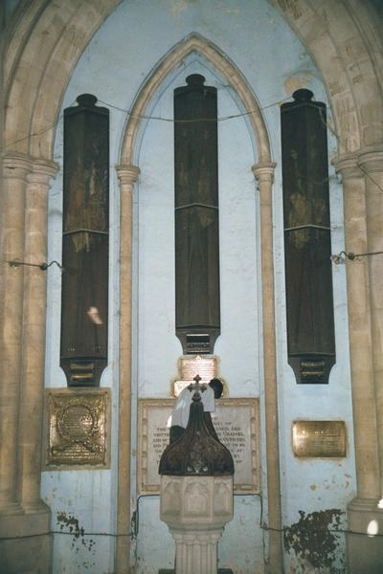
Glass mounted cabinets housing the regimental flags that were made to stand at the end of every 2nd or 3rd pew with a hole designed into the pew itself to serve the purpose.
A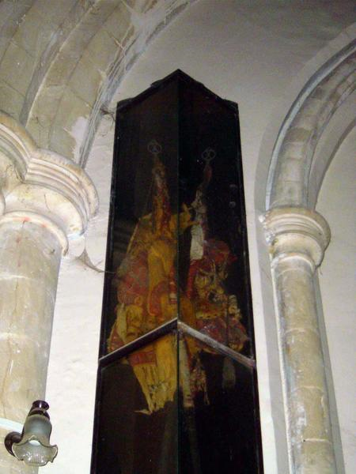
Close up of one of the glass cabinets with flags folded around their poles
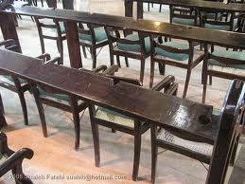
Circular slot at the end of the pew to place the flags & semi-circular slots for guns
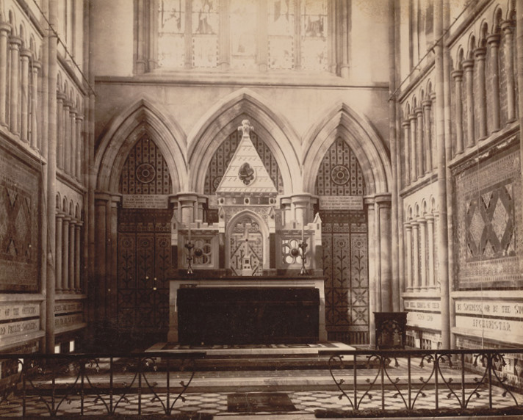
Picture of 1880-90 of the altar of Afghan church
I don’t know if i can copy this picture but if you can see the inscriptions at the sides of the altar .. these contain plaques with lists of names of soldiers and officials during the 31st Afghan war in different shades of marble. This seems to be an old picture 1880 – 90. The bottom of the railing right up front has the commemoration if I remember right.
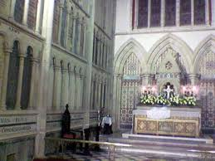Better image of the marble plaques with names
The wrought iron gates and railings were designed by the first batch of students from Sir JJ School of Art, as their first practical assignment. It exhibits a blend of Indian motifs set against Christian art,
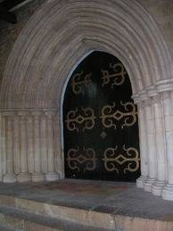The main door, project of students of J.J. School of Arts, (college still going strong btw, near Victoria Terminus)
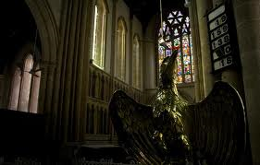
I don’t know what they call this phoenix/eagle but this is where the readings are done (as in St. Thomas Cathedral as well)

I end with this excerpt I just came across while looking for more information ..I did visit the church twice and stay for their service once. I intend going there again. This church is a beauty
Restore and return

Throughout our guided tour, Rev Graham’s tone lowers when we veer to its maintenance and a dwindling congregation. “ A partial restoration done five years ago was only a facelift for the interiors. We desperately need to repair the entire church for which funding is crucial,” he says, pointing to a deep crack that runs precariously close to the main altar. Next, he shows us the stained glass windows that were damaged by errant kids who use the churchyard to play cricket and football. In fact, we noticed the rampant discolouration and weeds sprouting on its outer façade. Earlier, funding for restoration was possible through the Church of North India, and donations and income from several film shoots done in its premises. Now, a bigger funding exercise appears imminent. A far cry from the 1850s, when banker Sir Cowasjee Jehangir readily donated Rs 75,000.

Uncertain destiny

What doesn’t help matters are the dwindling numbers of its congregation. “ Barely 40 people attend Sunday morning mass,” confesses Rev Graham. “ The Afghan Church is under tremendous stress from the builder lobby who want to take over this prime land by tempting churchgoers with incentives. This will be catastrophic not only for the community but also for Mumbai’s history and heritage. Associations like the Friends of Afghan Church Society need to be revived. Choral festivals, music concerts, guided walks and exhibitions keeping with the dignified spirit of the church can increase public interest in this beautiful legacy of ours,” believes Dr Dossal.

Unless heritage lovers and authorities join hands, Rev Graham and his parishioners might end up fighting a lonely battle to save this historic and handsome monument.

- Geographically, this church isn’t conveniently located. Plus, Navy Nagar has a floating population of Navy and military personnel. Some prefer to visit other churches in the neighbourhood. This is where we lose out.

Source: Mid-day, Page No 12, Dated: January 09, 2011

Information compiled from google sites and personal visits to the church

